Lab 8: Test-Driven Development with AI – Generating and Working with Test Cases

Name: Afrid Shaik

Roll no:2503a52385

Batch-13

Task Description -1 (Password Strength Validator – Apply AI in
Security Context):
• Task: Apply AI to generate at least 3 assert test cases for
is_strong_password(password) and implement the validator
function.
• Requirements:
o Password must have at least 8 characters.
o Must include uppercase, lowercase, digit, and special
character.
o Must not contain spaces.

Example Assert Test Cases:
assert is_strong_password(&quot;Abcd@123&quot;) == True
Week4 -
Monday
assert is_strong_password(&quot;abcd123&quot;) == False
assert is_strong_password(&quot;ABCD@1234&quot;) == True
prompt:
Generate Python test cases for is_strong_password(password) using assert statements. The password must have at least 8 characters, uppercase, lowercase, a digit, a special character, and no spaces. Then implement the function so that all test cases pass.
Task-1(test_password.py):
Input:

def is_strong_password(password):
# Check minimum length
if len(password) < 8:
return False

# Check for spaces
if " " in password:
return False

# Check uppercase, lowercase, digit and special character
has_upper = False
has_lower = False
has_digit = False
has_special = False

for char in password:
if char.isupper():
has_upper = True
elif char.islower():
has_lower = True
elif char.isdigit():
has_digit = True
else:
has_special = True

return has_upper and has_lower and has_digit and has_special

# AI-generated test cases
assert is_strong_password("Abcd@123") == True
assert is_strong_password("abcd123") == False
assert is_strong_password("Abcd@1234") == True

# Additional test cases
assert is_strong_password("Abcd @123") == False
assert is_strong_password("Abcd@xyz") == False
assert is_strong_password("Abcd1234") == False

print("All test cases passed successfully!")

output:
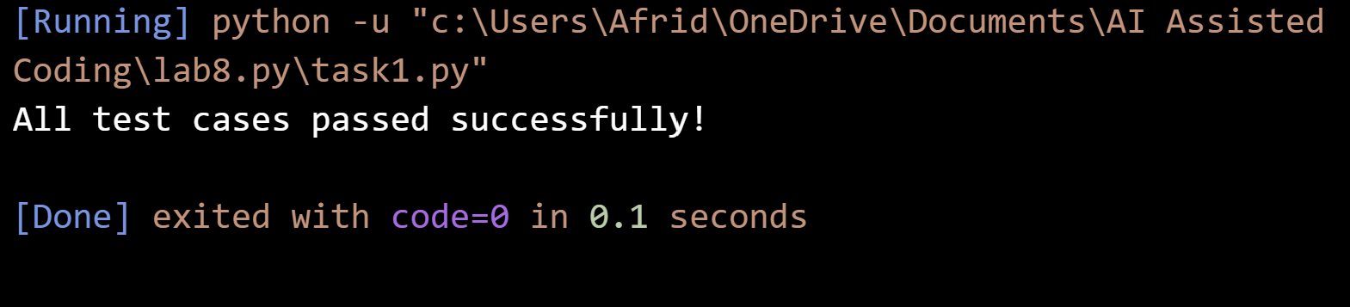
Task-1(password_validator)
Input:
def is_strong_password(password):
# Must be at least 8 characters
if len(password) < 8:
return False

# Must not contain spaces
if " " in password:
return False

has_upper = False
has_lower = False
has_digit = False
has_special = False

for char in password:
if char.isupper():
has_upper = True
elif char.islower():
has_lower = True
elif char.isdigit():
has_digit = True
else:
has_special = True

return has_upper and has_lower and has_digit and has_special

output:
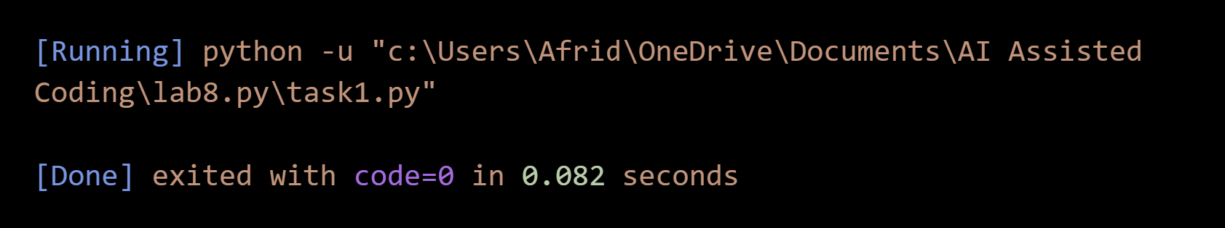
justification:
AI was used to generate test cases and implement the password strength validator. The tests check the required password conditions, helping identify errors and ensure that the function works correctly and securely.

Task Description #2 (Number Classification with Loops – Apply
AI for Edge Case Handling):
• Task: Use AI to generate at least 3 assert test cases for a
classify_number(n) function. Implement using loops.

• Requirements:
o Classify numbers as Positive, Negative, or Zero.
o Handle invalid inputs like strings and None.
o Include boundary conditions (-1, 0, 1).

Example Assert Test Cases:
assert classify_number(10) == &quot;Positive&quot;
assert classify_number(-5) == &quot;Negative&quot;
assert classify_number(0) == &quot;Zero&quot;
prompt:
Generate assert test cases for classify_number(n) to classify numbers as Positive, Negative, or Zero. Handle invalid inputs such as strings and None, and test boundary values -1, 0, and 1. Implement the function using a loop.

Input:
def classify_number(n):
if not isinstance(n, (int, float)):
return "Invalid Input"

for i in range(1):
if n > 0:
return "Positive"
elif n < 0:
return "Negative"
else:
return "Zero"

# Test cases
assert classify_number(10) == "Positive"
assert classify_number(-5) == "Negative"
assert classify_number(0) == "Zero"

# Boundary conditions
assert classify_number(-1) == "Negative"
assert classify_number(1) == "Positive"

# Invalid inputs
assert classify_number("10") == "Invalid Input"
assert classify_number(None) == "Invalid Input"

print("All test cases passed successfully!")
output:
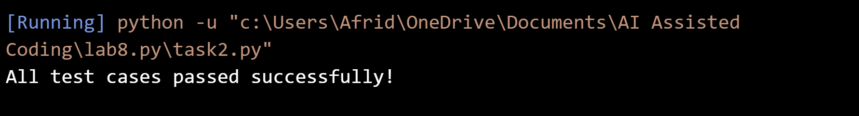
Justification:
AI was used to generate test cases covering normal values, boundary conditions, and invalid inputs. The implementation was tested to ensure that positive, negative, zero, and invalid values are classified correctly.

Task Description #3 (Anagram Checker – Apply AI for String
Analysis):
• Task: Use AI to generate at least 3 assert test cases for
is_anagram(str1, str2) and implement the function.
• Requirements:
o Ignore case, spaces, and punctuation.
o Handle edge cases (empty strings, identical words).
Example Assert Test Cases:
assert is_anagram(&quot;listen&quot;, &quot;silent&quot;) == True
assert is_anagram(&quot;hello&quot;, &quot;world&quot;) == False
assert is_anagram(&quot;Dormitory&quot;, &quot;Dirty Room&quot;) == True

prompt:
Generate at least 3 assert test cases for is_anagram(str1, str2). Ignore case, spaces, and punctuation, and handle empty strings and identical words. Then implement the function so all tests pass.
Task-3:
Input:
def is_anagram(str1, str2):
# Remove spaces and punctuation, and convert to lowercase
clean1 = ""
clean2 = ""

for char in str1.lower():
if char.isalnum():
clean1 += char

for char in str2.lower():
if char.isalnum():
clean2 += char

return sorted(clean1) == sorted(clean2)

# Test cases
assert is_anagram("listen", "silent") == True
assert is_anagram("hello", "world") == False
assert is_anagram("Dormitory", "Dirty Room") == True

# Edge cases
assert is_anagram("", "") == True
assert is_anagram("Hello", "hello") == True

print("All test cases passed successfully!")
output:
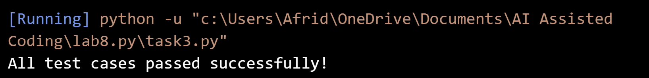

Justification:
AI was used to generate test cases for checking anagrams, including normal cases and edge cases. The function processes strings by ignoring case, spaces, and punctuation and was verified using assert tests.

Task Description #4 (Inventory Class – Apply AI to Simulate Real-
World Inventory System):
• Task: Ask AI to generate at least 3 assert-based tests for an
Inventory class with stock management.
• Methods:

o add_item(name, quantity)
o remove_item(name, quantity)
o get_stock(name)
Example Assert Test Cases:
inv = Inventory()
inv.add_item(&quot;Pen&quot;, 10)
assert inv.get_stock(&quot;Pen&quot;) == 10
inv.remove_item(&quot;Pen&quot;, 5)
assert inv.get_stock(&quot;Pen&quot;) == 5
inv.add_item(&quot;Book&quot;, 3)
assert inv.get_stock(&quot;Book&quot;) == 3

promt:
Generate at least 3 assert-based tests for an Inventory class with add_item(), remove_item(), and get_stock() methods. Test adding, removing, and checking item quantities. Then implement the class so all assertions pass.
Input:
class Inventory:

def __init__(self):
self.stock = {}

def add_item(self, name, quantity):
if name in self.stock:
self.stock[name] += quantity
else:
self.stock[name] = quantity

def remove_item(self, name, quantity):
if name in self.stock:
self.stock[name] -= quantity

def get_stock(self, name):
return self.stock.get(name, 0)

# Test cases
inv = Inventory()

inv.add_item("Pen", 10)
assert inv.get_stock("Pen") == 10

inv.remove_item("Pen", 5)
assert inv.get_stock("Pen") == 5

inv.add_item("Book", 3)
assert inv.get_stock("Book") == 3

print("All assertions passed successfully!")
output:
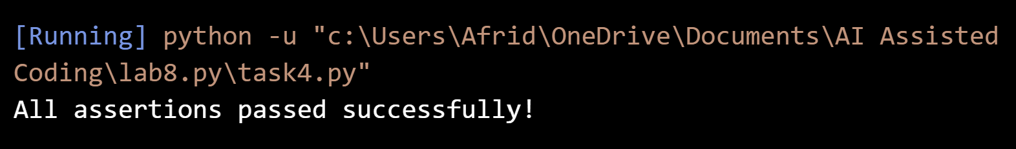
Justification:
AI was used to generate test cases and implement an Inventory class. The tests verify adding, removing, and checking stock quantities, ensuring that the inventory system works correctly.

Task Description #5 (Date Validation &amp; Formatting – Apply AI for Data Validation):
• Task: Use AI to generate at least 3 assert test cases for
validate_and_format_date(date_str) to check and convert
dates.
• Requirements:
o Validate &quot;MM/DD/YYYY&quot; format.
o Handle invalid dates.
o Convert valid dates to &quot;YYYY-MM-DD&quot;.
Example Assert Test Cases:
assert validate_and_format_date(&quot;10/15/2023&quot;) == &quot;2023-10-15&quot;
assert validate_and_format_date(&quot;02/30/2023&quot;) == &quot;Invalid Date&quot;
assert validate_and_format_date(&quot;01/01/2024&quot;) == &quot;2024-01-01&quot;
prompt:
Generate at least 3 assert test cases for validate_and_format_date(date_str). Validate the MM/DD/YYYY format, handle invalid dates, and convert valid dates to YYYY-MM-DD. Include edge cases such as leap years.

input:
from datetime import datetime
def validate_and_format_date(date_str):
try:
date = datetime.strptime(date_str, "%m/%d/%Y")
return date.strftime("%Y-%m-%d")
except ValueError:
return "Invalid Date"

# Test cases
assert validate_and_format_date("10/15/2023") == "2023-10-15"
assert validate_and_format_date("02/30/2023") == "Invalid Date"
assert validate_and_format_date("01/01/2024") == "2024-01-01"

# Edge cases
assert validate_and_format_date("02/29/2024") == "2024-02-29"
assert validate_and_format_date("13/01/2023") == "Invalid Date"

print("All assertions passed successfully!")

output:
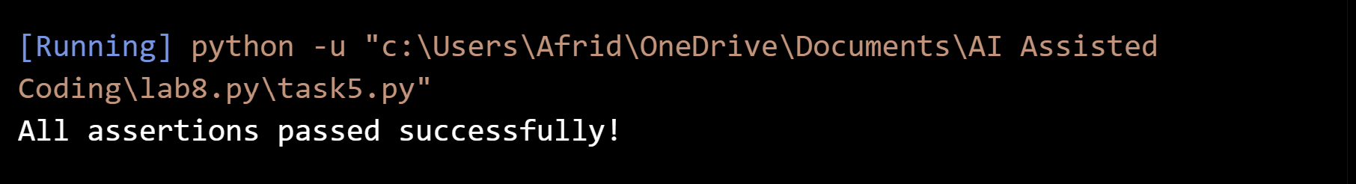
Justification:
AI was used to generate test cases for date validation and formatting. The tests check valid dates, invalid dates, and edge cases such as leap years to ensure reliable date handling.

